AI Use Declaration Form
Course: Introduction to Artificial Intelligence
Lab Title: Lab 1 Part A — Uninformed Search Algorithms
Student Name: Victoria Brown Afari
Student ID: 94692028
GitHub Repository Link: https://github.com/victoriabrowwn/Intro-To-AI-Lab1.git
Date Submitted: 20/06/26

1. AI Use Summary
Question | Student Response
Did you use any AI tool for this lab? | Yes
Estimated percentage of the work influenced by AI | 20%
Did you attach evidence of AI use where applicable? | Yes

2. Details of AI Use
Complete the table below for each AI tool used. Add more rows where necessary.
Name of AI Tool Used | Purpose for Using the Tool | Prompt or Instruction Given to the Tool | Part(s) of the Work Influenced by the Tool | How I Verified, Edited, or Improved the AI Output
Chat GPT | For creating grids, creating errors | Help me create a matrix of 0s and 1s to form a maze | Creating the maze | Verified 0s and 1s
Claude | Correcting errors | Help me correct the error in this code. | Errors in block of codes | Corrected errors indicated

3. Attachment of AI Output Evidence
Where required, attach evidence of AI use. Tick all that apply. Add more rows where necessary.
Evidence Type | Attached? (Yes, No, N/A) | File Name
AI-generated draft
Prompt history | Yes | https://chatgpt.com/share/6a372e58-2000-83ea-90cd-b6e3fb845c30
Screenshot of AI interaction | Yes
Exported AI conversation
AI-generated code snippet | Yes
Revised version showing student input

4. Student Declaration
I declare that:
Declaration Statement | Response (Yes/No)
The submitted work is my own work. | Yes
Any use of AI tools has been clearly declared in this form. | Yes
The prompts, instructions, and AI-generated outputs have been disclosed where applicable. | Yes
I reviewed, tested, edited, and improved any AI-generated content before submission. | Yes
My AI usage does not exceed 25% of the entire work. | Yes
I understand that undeclared or excessive AI use may be treated as academic misconduct. | Yes

Attachments
Prompt: Create Your Own Maps Create at least two additional maps. Your maps should be meaningfully different. For example:
A map with a long narrow corridor.
A map with many dead ends.
A map where DFS is likely to enter dead ends before finding the goal.
A larger map, such as 15 × 15 or 20 × 20.
For each map:

run BFS, DFS, DLS, and IDS,
record the metrics,
visualise at least one solution path,
write a short interpretation.

Help me create a matrix of 0s and 1s to form a maze
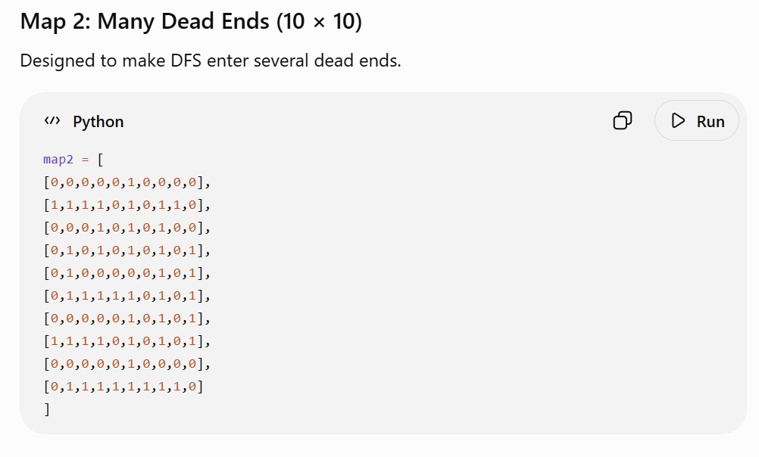
Prompt: Create at least two additional maps. At least one of them must be a WeightedGridProblem with meaningful terrain costs.

Design suggestions:

A heuristic trap: a U-shaped obstacle opening away from the goal, so Greedy (and even A*) must expand many nodes inside the pocket before backing out.
A cheap long way vs expensive short way map, where the optimal path is much longer (in moves) than the direct path.
A larger map, such as 15 × 15 or 20 × 20, to make the UCS-vs-A* node-count gap dramatic.
A map where Weighted A* with W = 2 returns a visibly different path from standard A*.
For each map:

run UCS, Greedy, A*, and Weighted A*,
record the metrics with show_results,
visualise at least one solution path,
write a short interpretation (2–4 sentences): which algorithm "won", and on which metric?

Help me create a matrix of 0s and 1s to form a maze
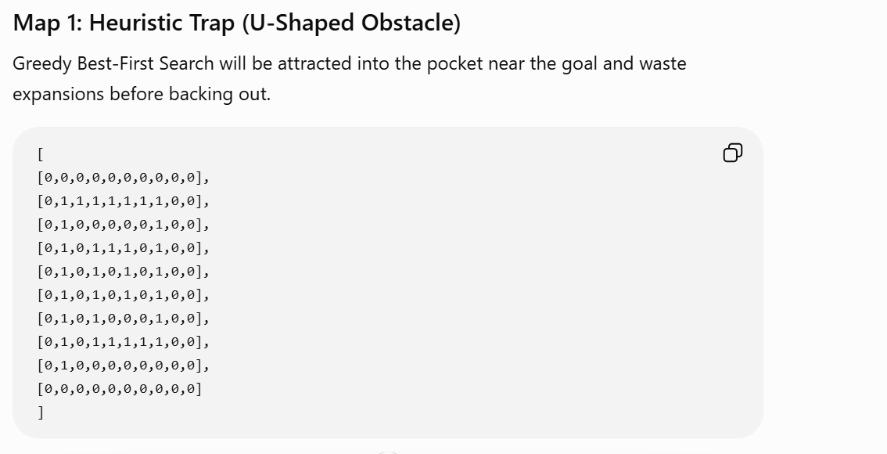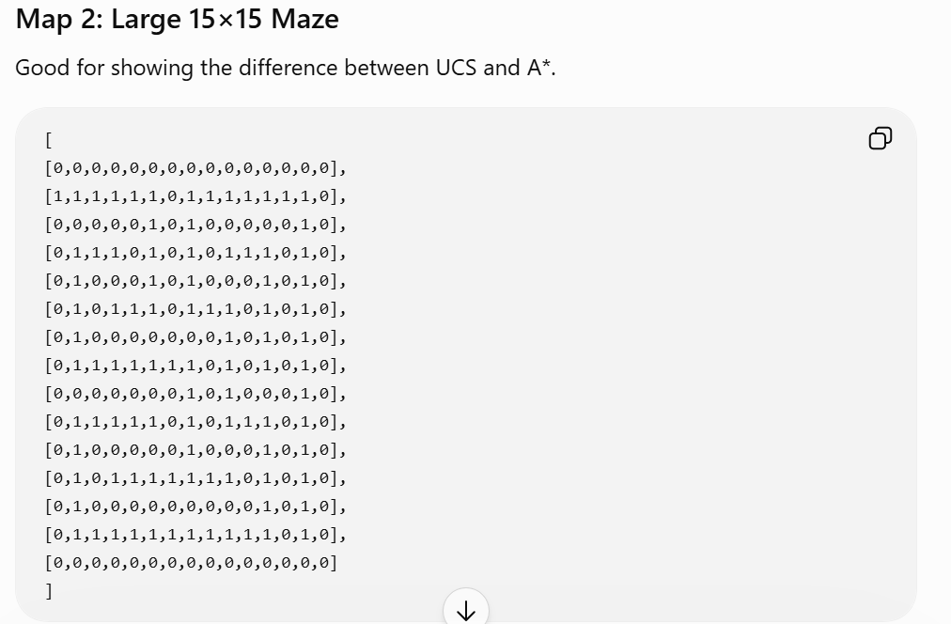

Prompt: Make a maze using 15x15 matrix using 0s and 1s
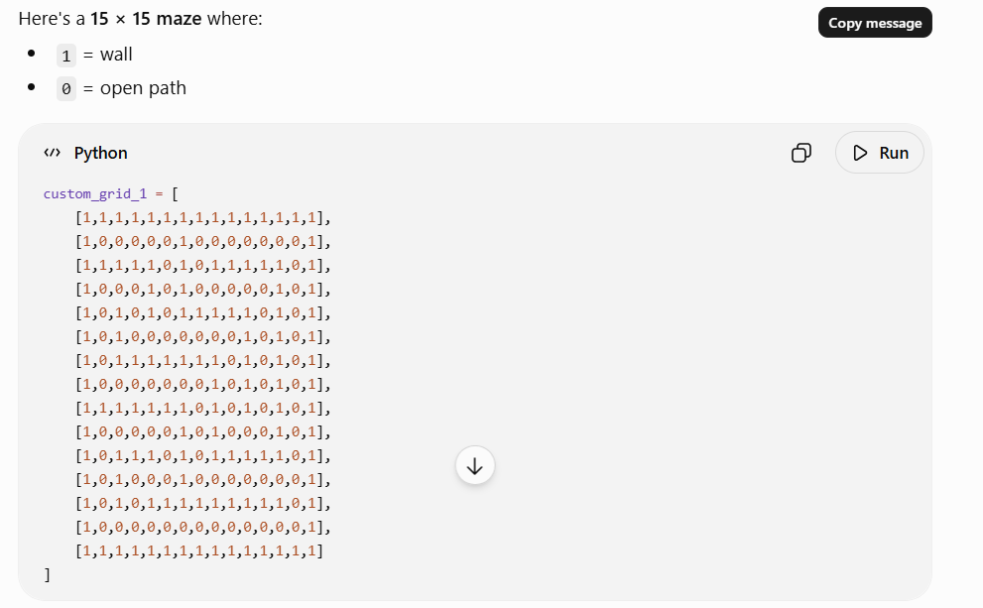

Links:
- https://chatgpt.com/share/6a372e58-2000-83ea-90cd-b6e3fb845c30
- https://chatgpt.com/share/6a372eb4-1ab4-83ea-a9c3-cb35c7a29548

Student Signature: 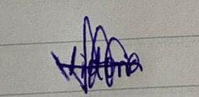
Date: 20/06/26

